**Sunkari Manohar**

**Python Assessment 3 - 14/12/2023**

**Break Statement:**

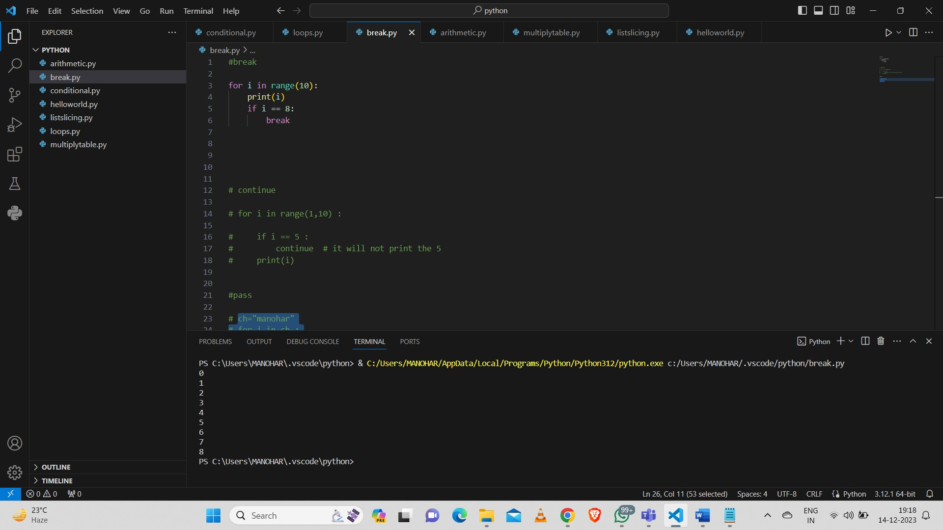

**Continue Statement:**

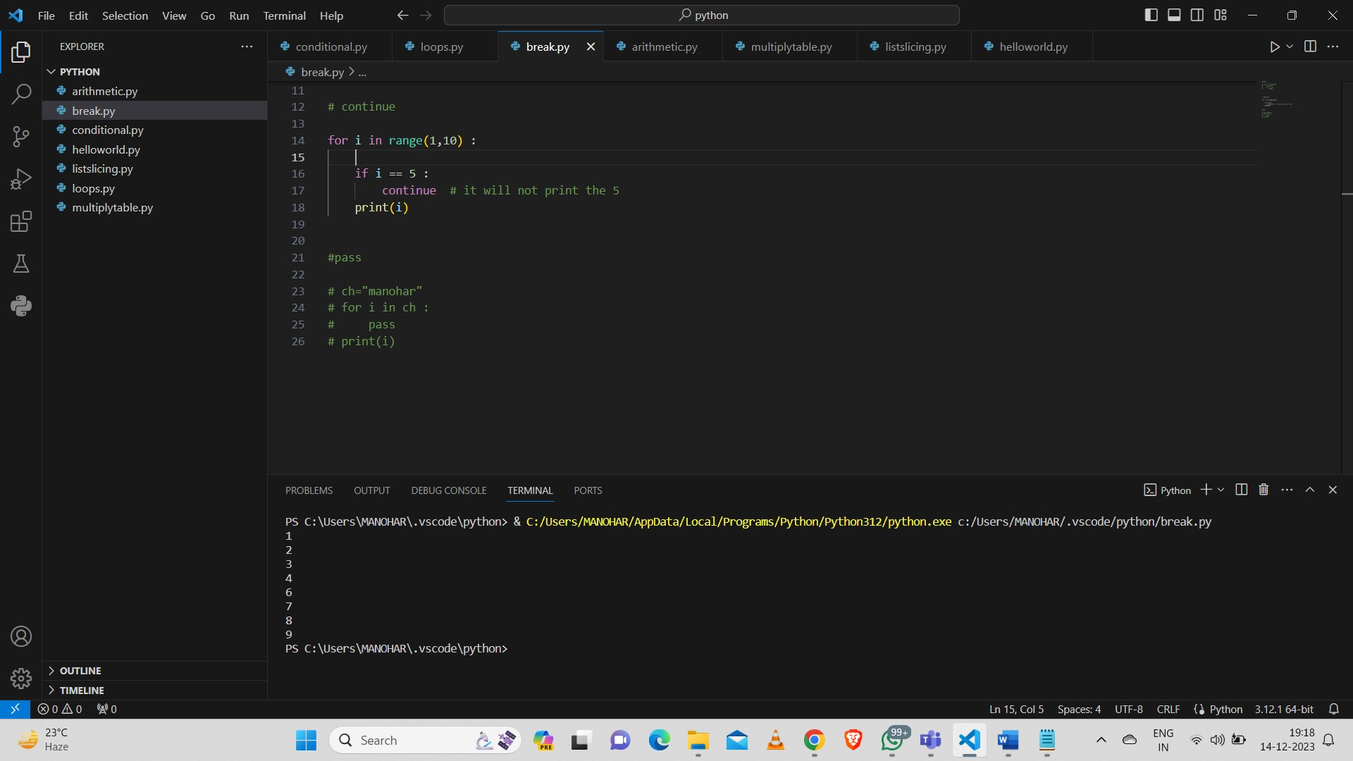

**Pass Statement:**

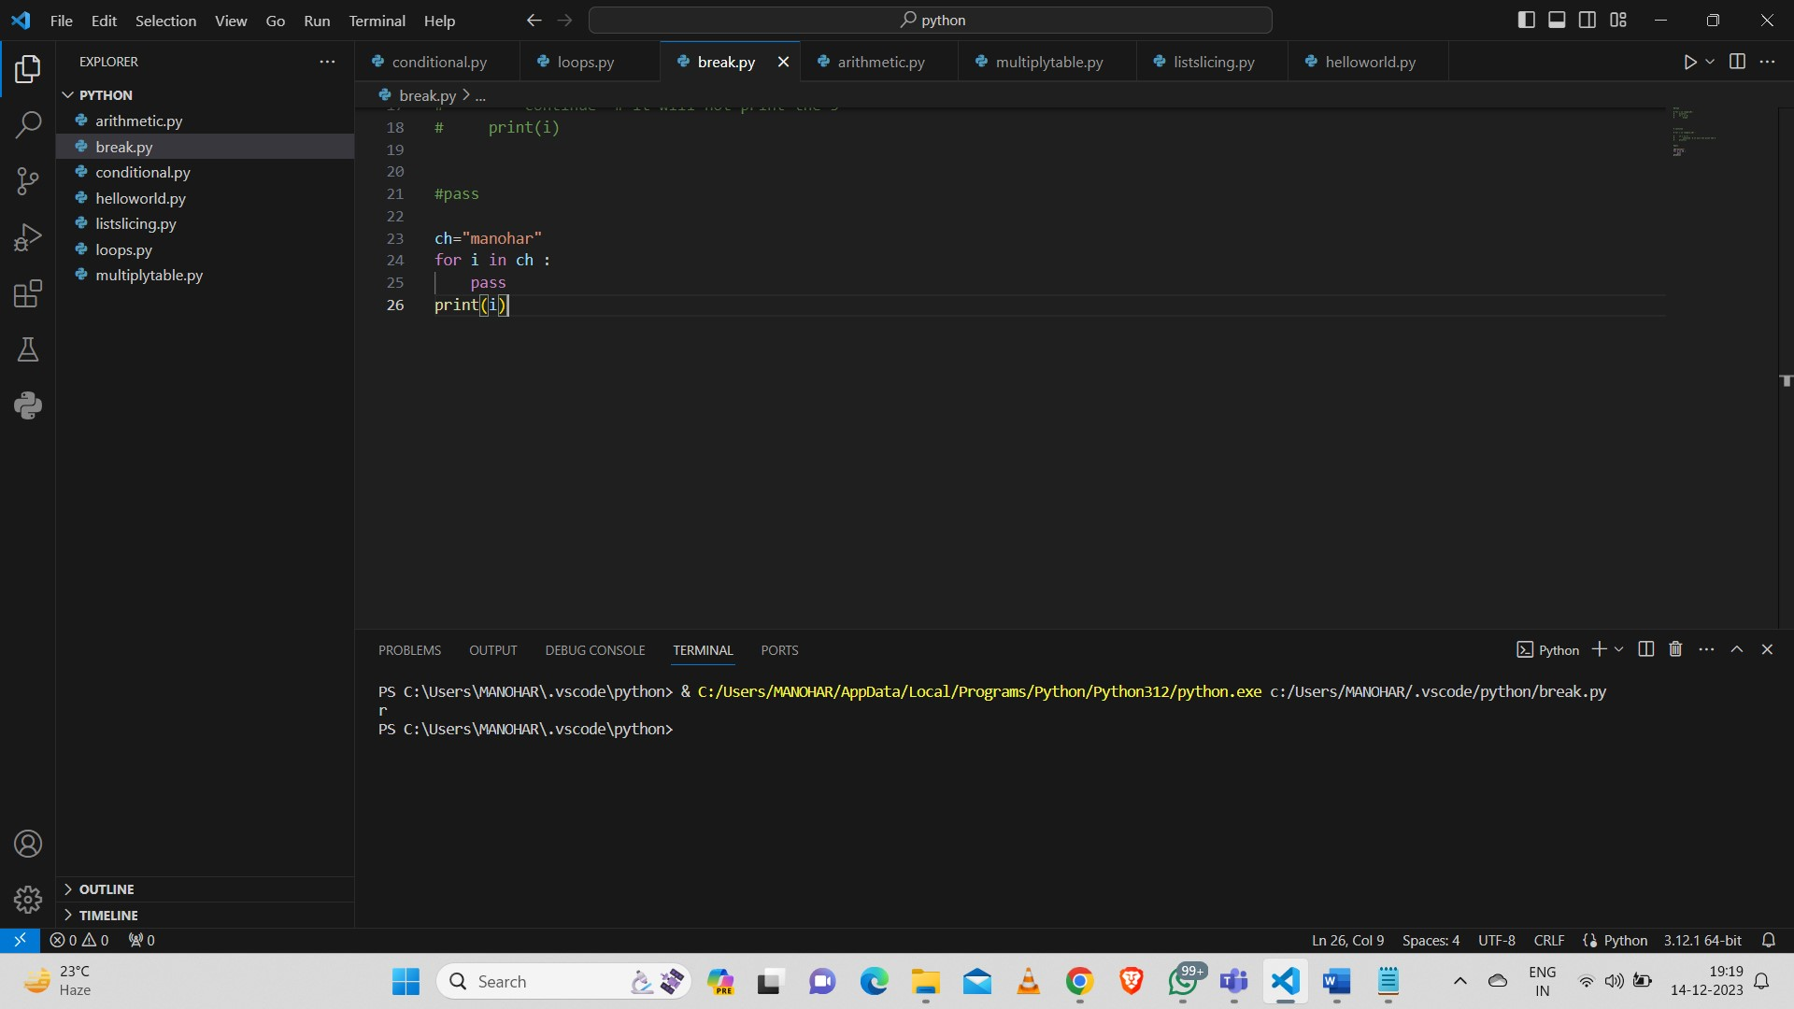

**Multiplying table:**

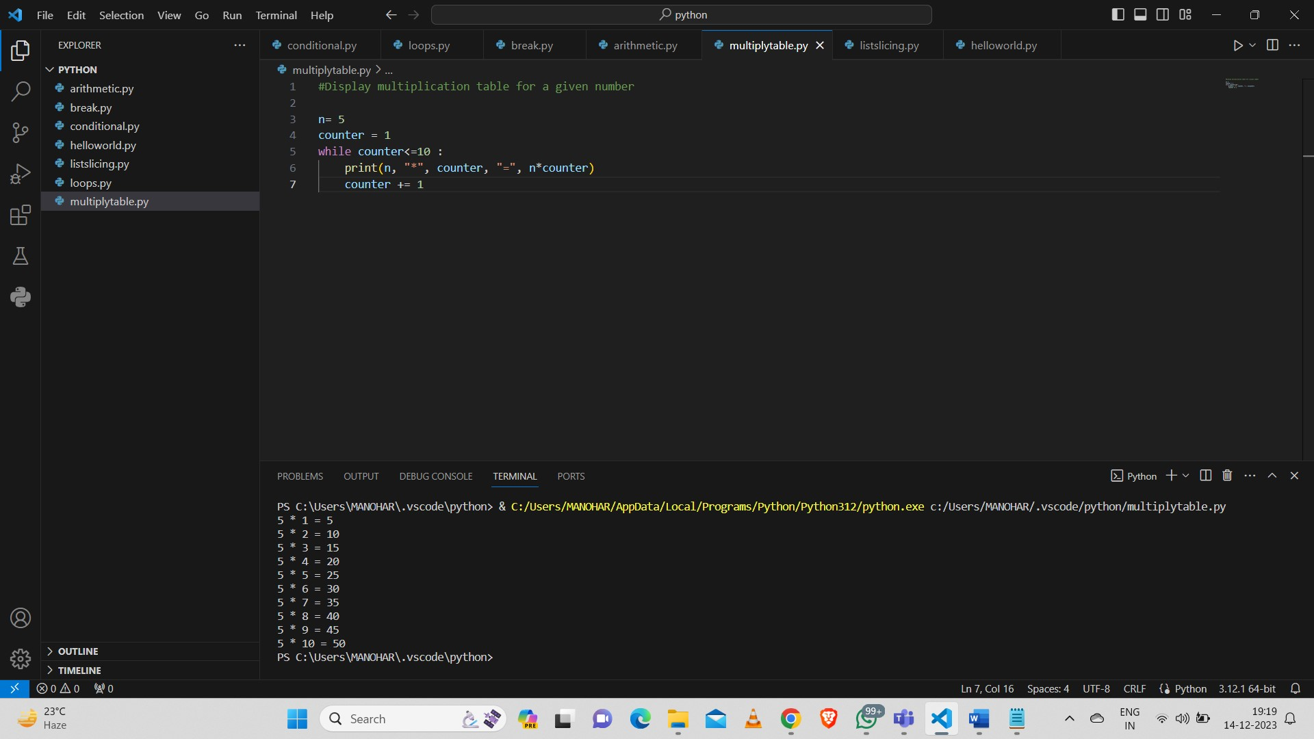

**Slicing:**

**List Slicing:**

**Syntax [start: stop: step count]**

**Example 1:**

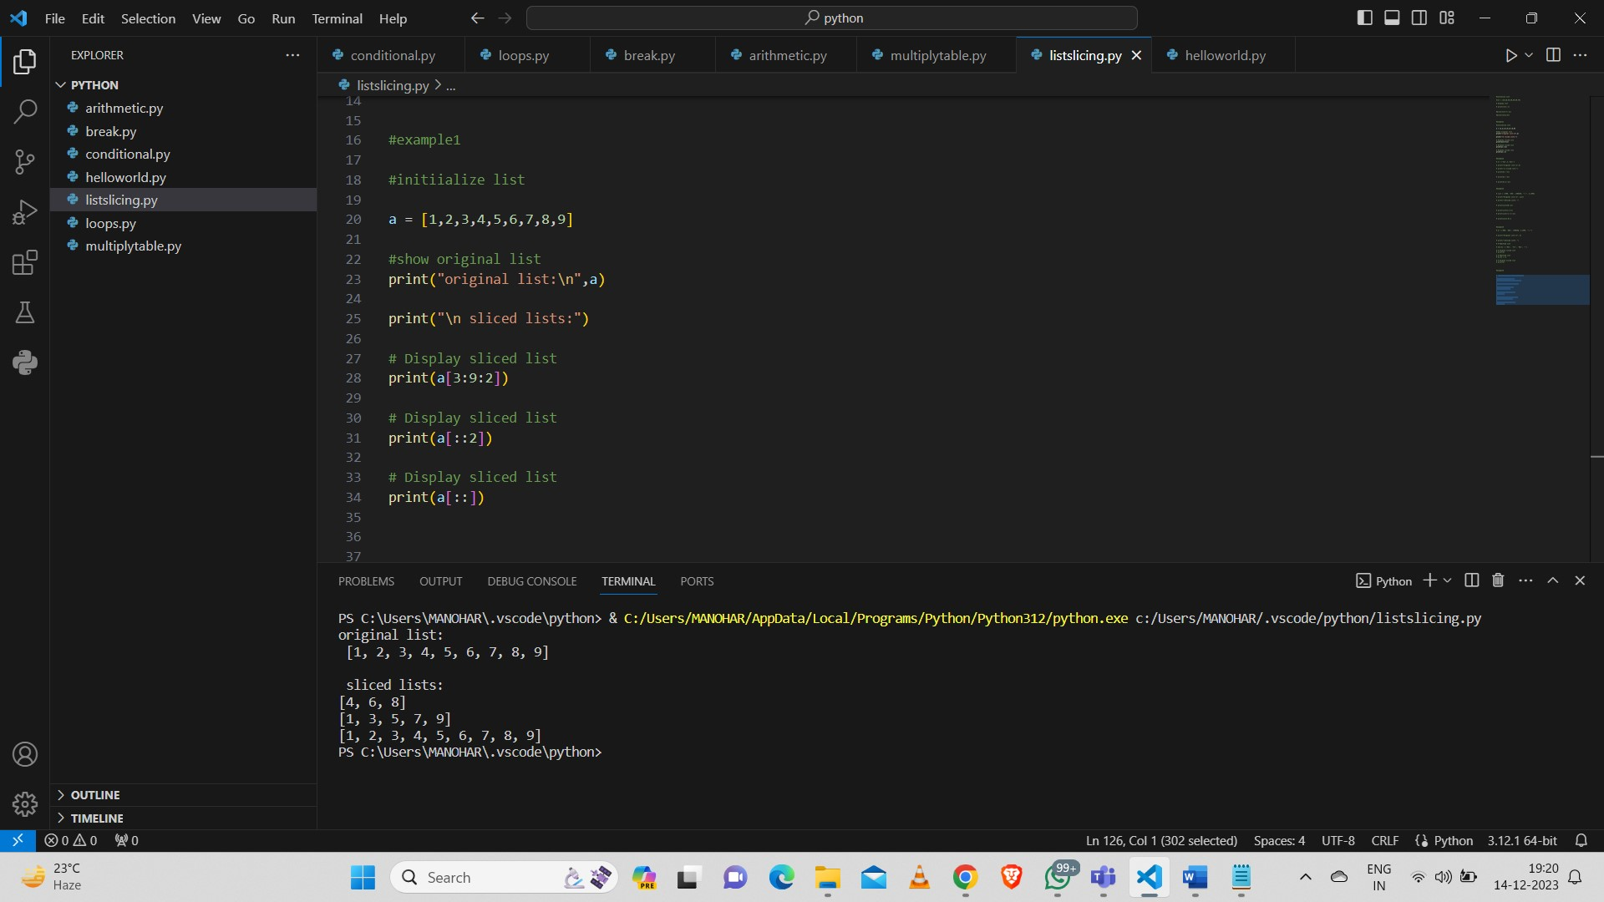

**Example 2:**

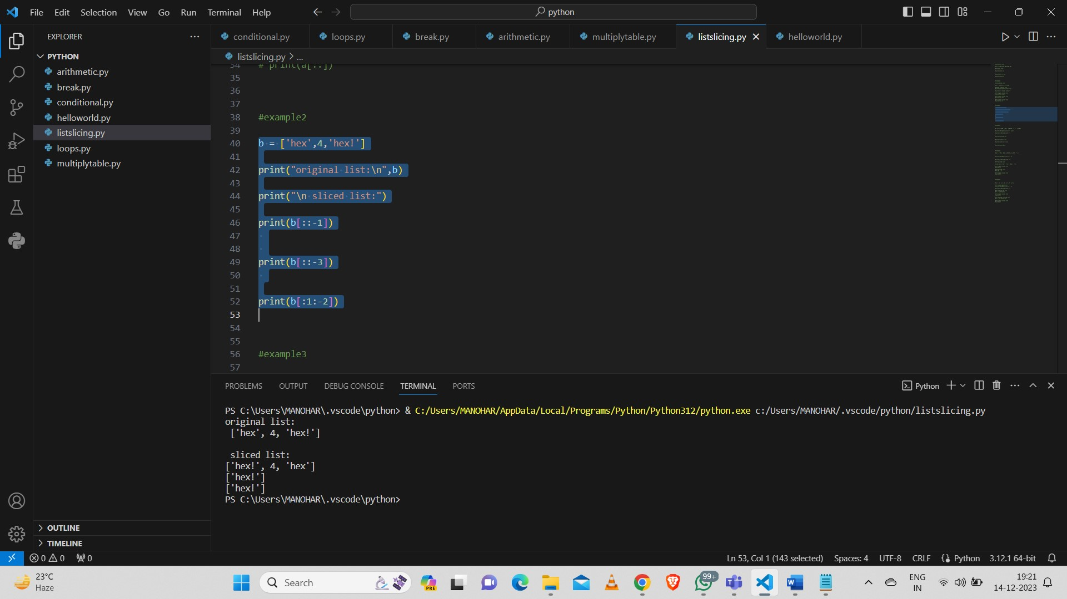

**Example 3:**

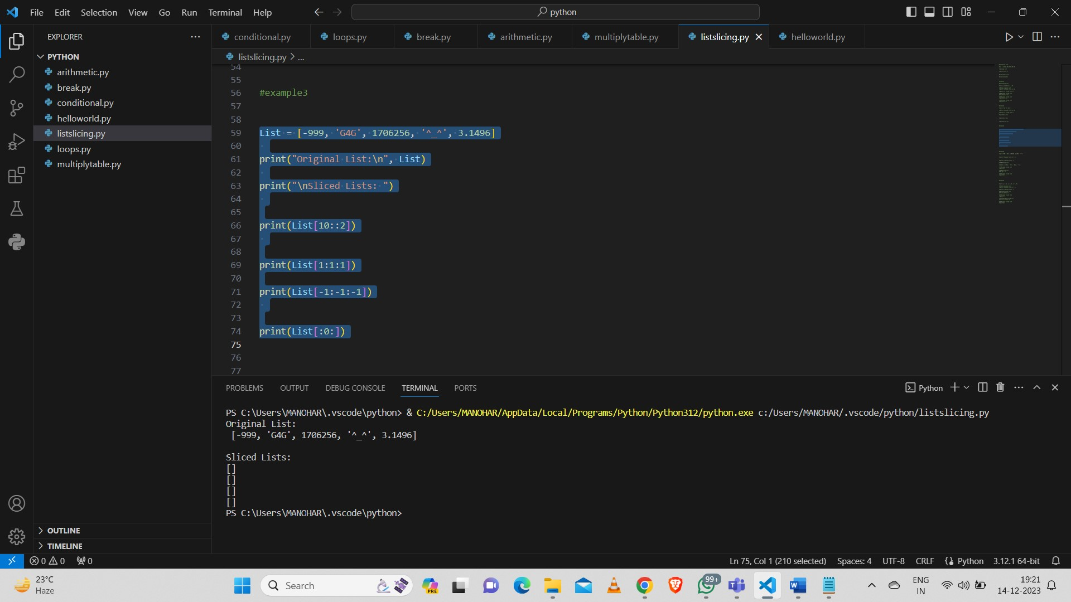

**Example 4: Modifying list**

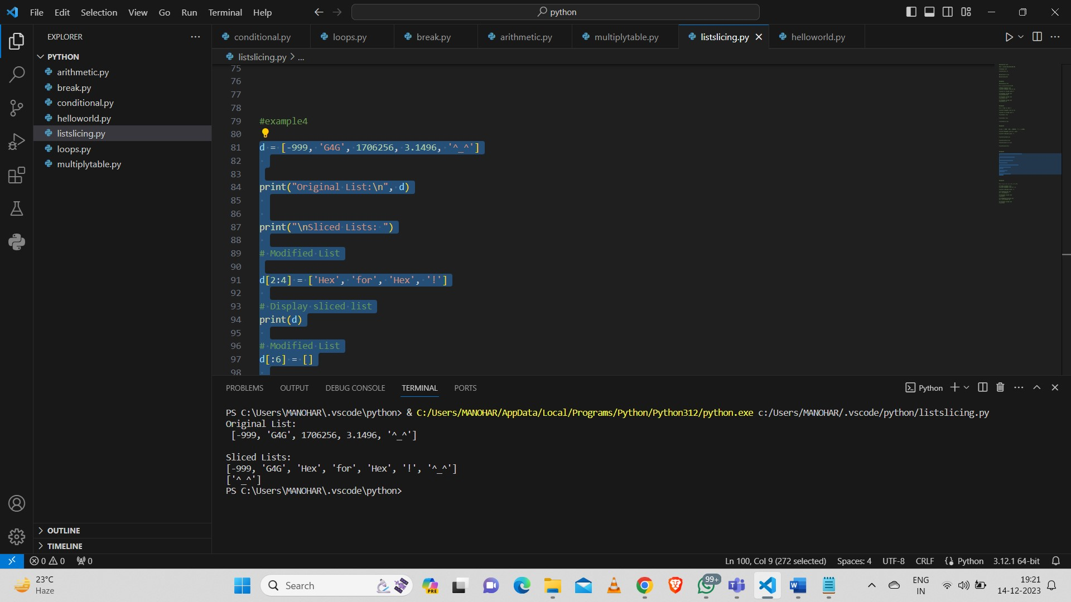

**Example 5:**

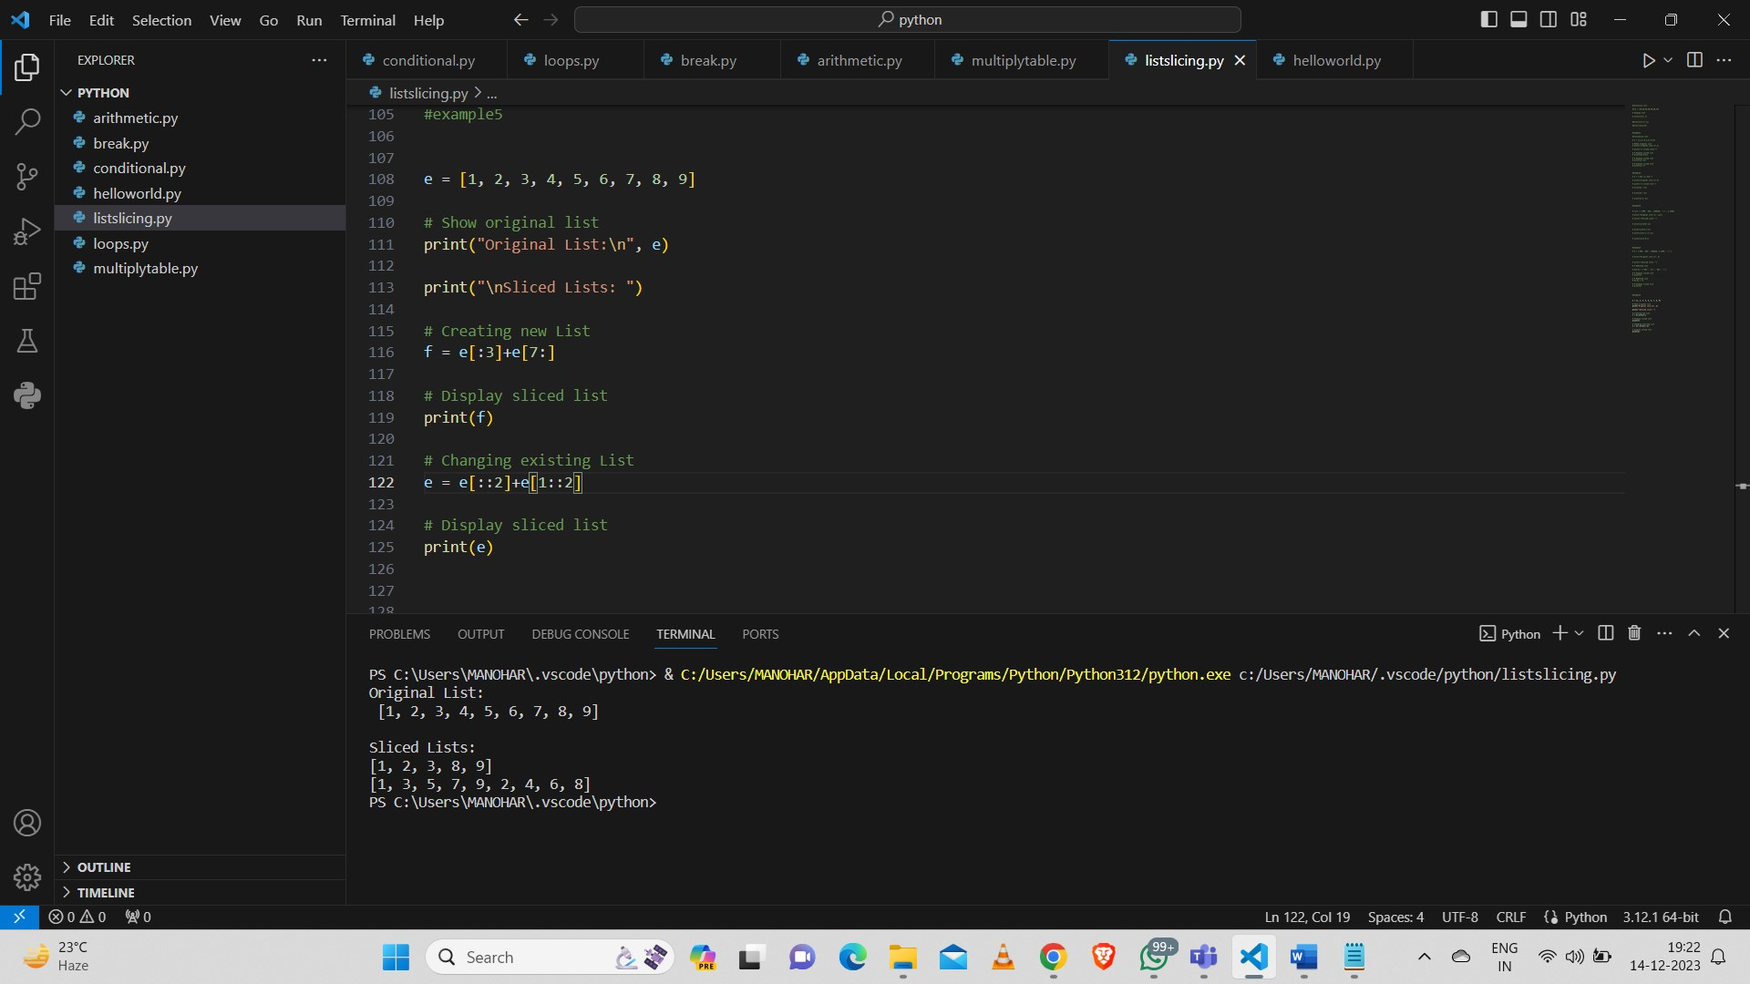

**Operators:**

**Arithmetic Operators:**

**+, -, *, /, %, //, \*\***

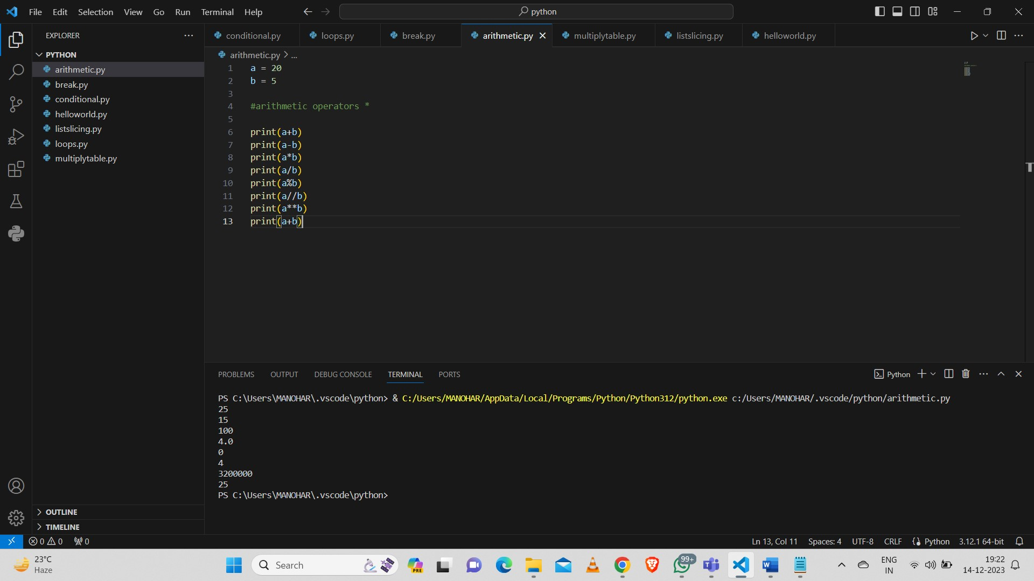

**Logical Operators:**

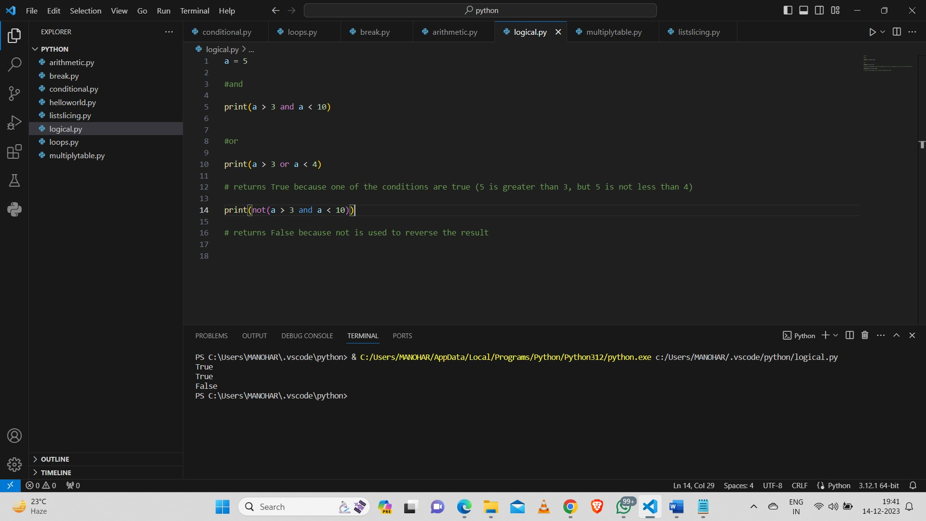

**Comparison operators:**

**==, !=, <, >, <=, >=**

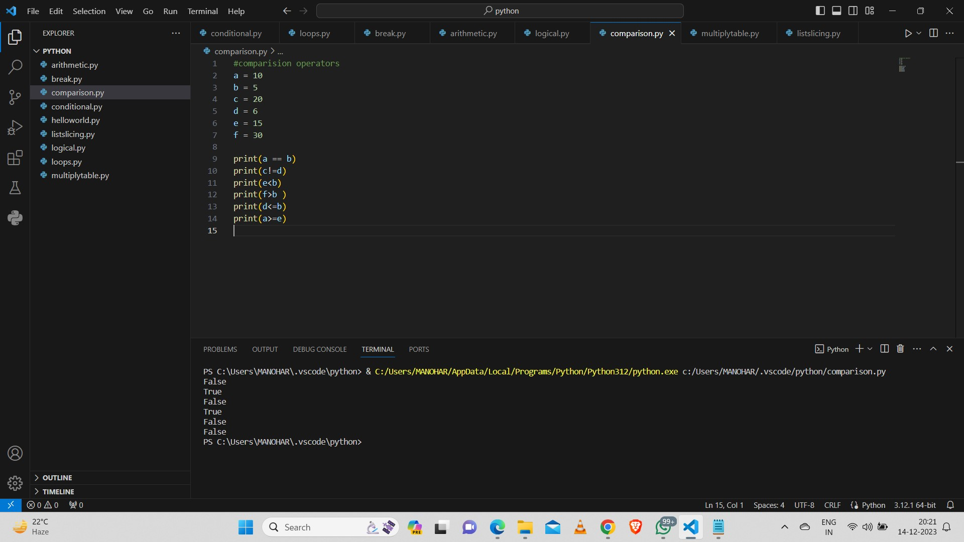

**Membership Operators:**

**In, Not In:**

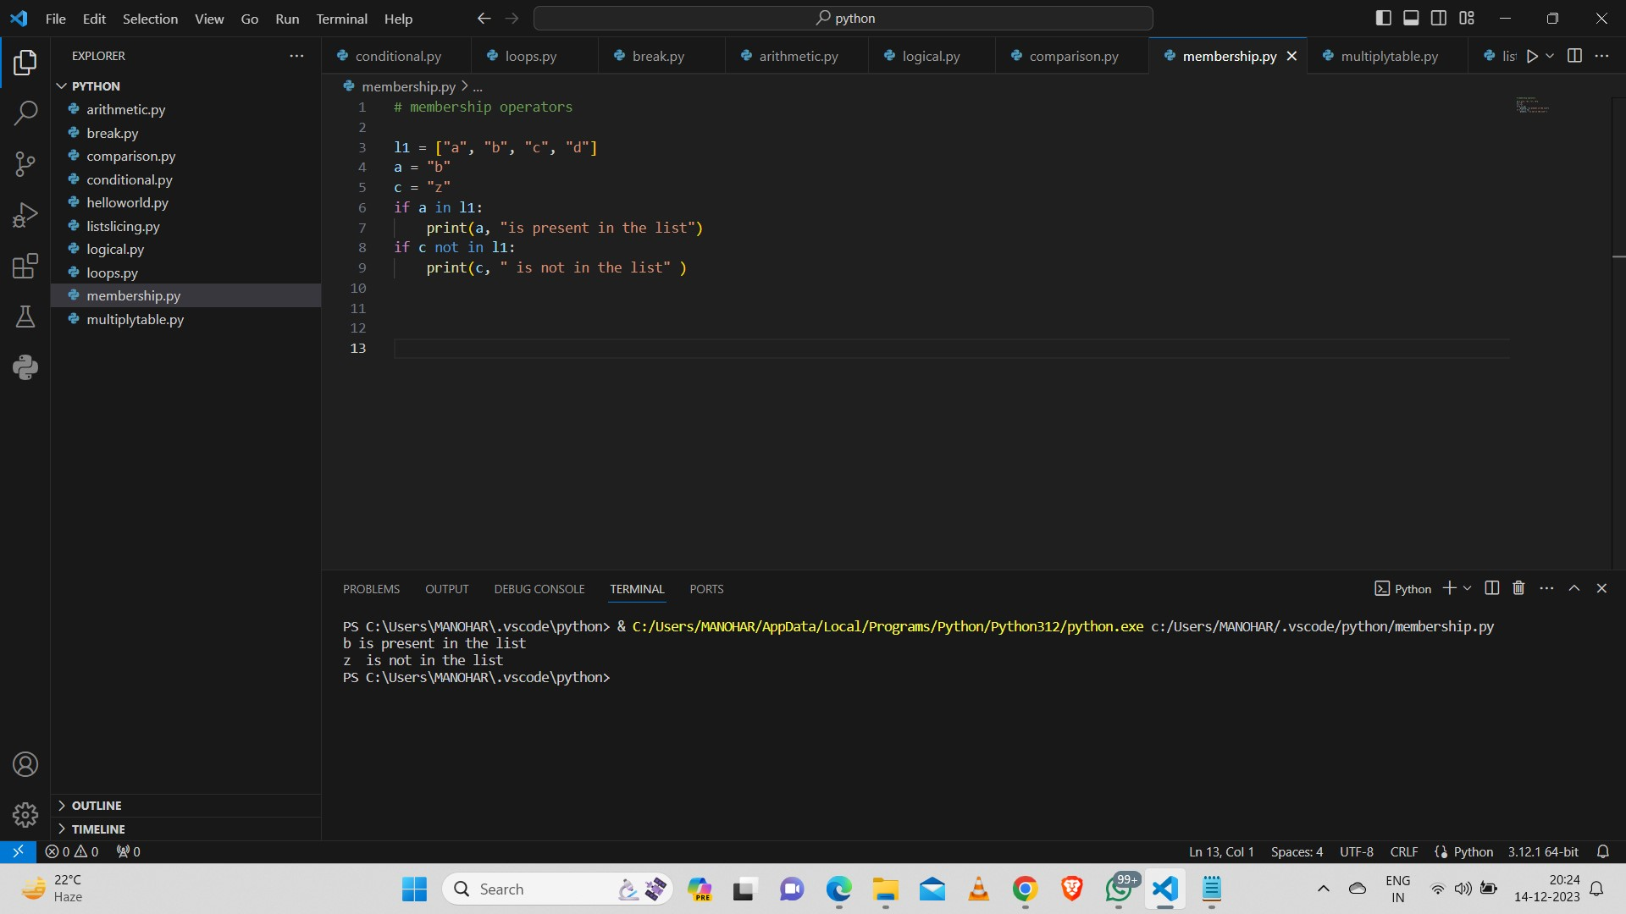

**Bitwise Operators:**

